Kinematics in One Dimension

1) If the acceleration of an object is negative, the object must be slowing down.
A) True
B) False

2) If the graph of the position as a function of time for an object is a horizontal line, that object cannot be accelerating.
A) True
B) False

3) If an object is accelerating toward a point, then it must be getting closer and closer to that point.
A) True
B) False

4) When can we be certain that the average velocity of an object is always equal to its instantaneous velocity?
A) always
B) never
C) only when the velocity is constant
D) only when the acceleration is constant
E) only when the acceleration is changing at a constant rate

5) Suppose that an object is moving with constant nonzero acceleration. Which of the following is an accurate statement concerning its motion?
A) In equal times its speed changes by equal amounts.
B) In equal times its velocity changes by equal amounts.
C) In equal times it moves equal distances.
D) A graph of its position as a function of time has a constant slope.
E) A graph of its velocity as a function of time is a horizontal line.
6) Suppose that a car traveling to the west (the -x direction) begins to slow down as it approaches a traffic light. Which statement concerning its acceleration in the x direction is correct?
A) Both its acceleration and its velocity are positive.
B) Both its acceleration and its velocity are negative.
C) Its acceleration is positive but its velocity is negative.
D) Its acceleration is negative but its velocity is positive.

7) The motion of a particle is described in the velocity versus time graph shown in the figure. We can say that its speed
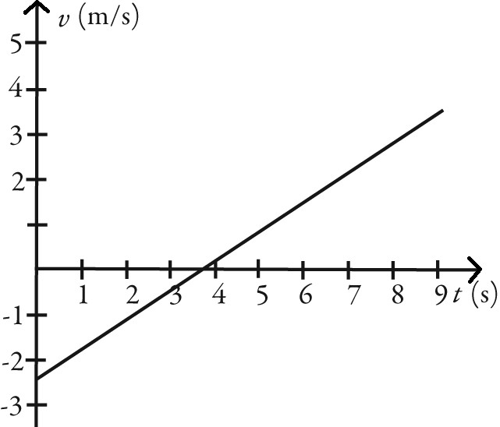
A) increases.
B) decreases.
C) increases and then decreases.
D) decreases and then increases.

8) The motions of a car and a truck along a straight road are represented by the velocity-time graphs in the figure. The two vehicles are initially alongside each other at time t = 0. At time T, what is true about these two vehicles since time t = 0?

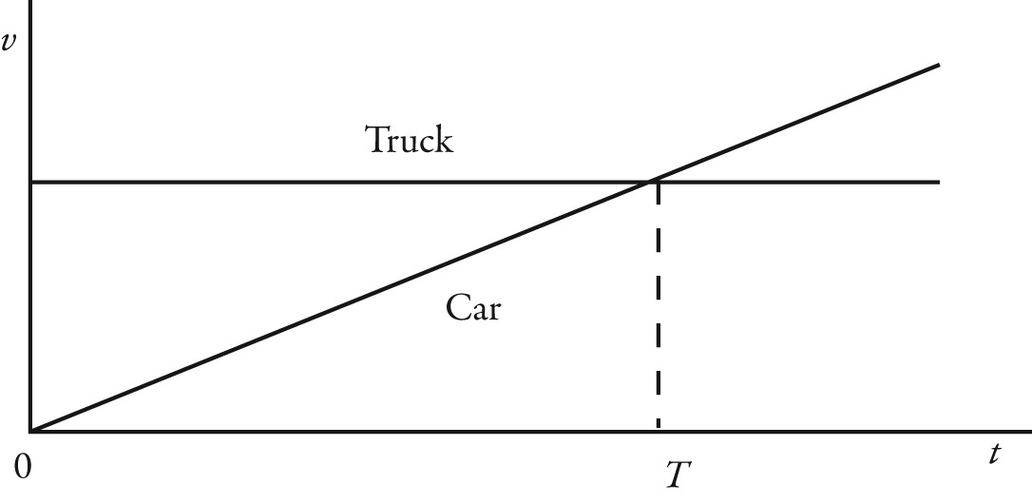
A) The truck will have traveled further than the car.
B) The car will have traveled further than the truck.
C) The truck and the car will have traveled the same distance.
D) The car will be traveling faster than the truck.
9) The graph in the figure shows the position of an object as a function of time. The letters H-L represent particular moments of time. At which moments shown (H, I, etc.) is the speed of the object
(a) the greatest?
(b) the smallest?
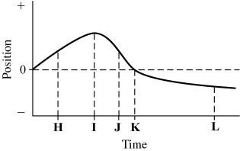
10) The figure shows the position of an object (moving along a straight line) as a function of time. Assume two significant figures in each number. Which of the following statements about this object is true over the interval shown?

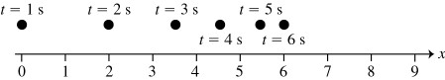

A) The object is accelerating to the left.
B) The object is accelerating to the right.
C) The acceleration of the object is in the same direction as its velocity.
D) The average speed of the object is 1.0 m/s.
11) The figure shows the graph of the position x as a function of time for an object moving in the straight line (the x-axis). Which of the following graphs best describes the velocity along the x-axis as a function of time for this object?
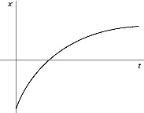
A)
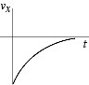
B)
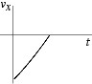
C)
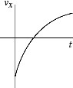
D)
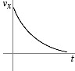
E)
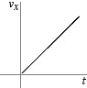
12) An object is moving with constant non-zero acceleration along the +x-axis. A graph of the velocity in the x direction as a function of time for this object is
A) a horizontal straight line.
B) a vertical straight line.
C) a straight line making an angle with the time axis.
D) a parabolic curve.
13) An object is moving in a straight line along the x-axis. A plot of its velocity in the x direction as a function of time is shown in the figure. Which graph represents its acceleration in the x direction as a function of time?
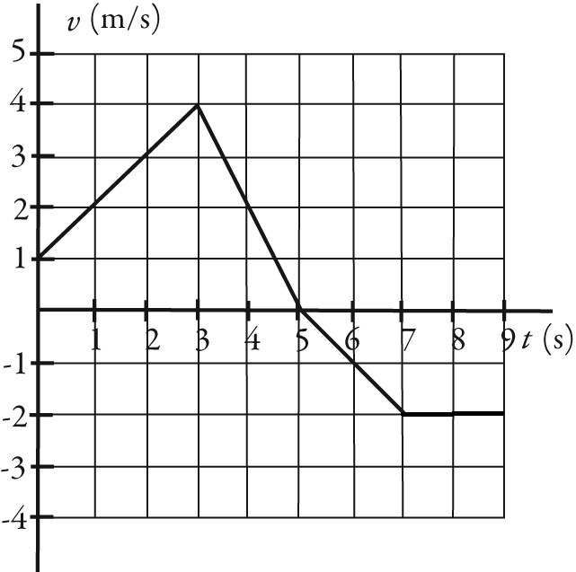
A)
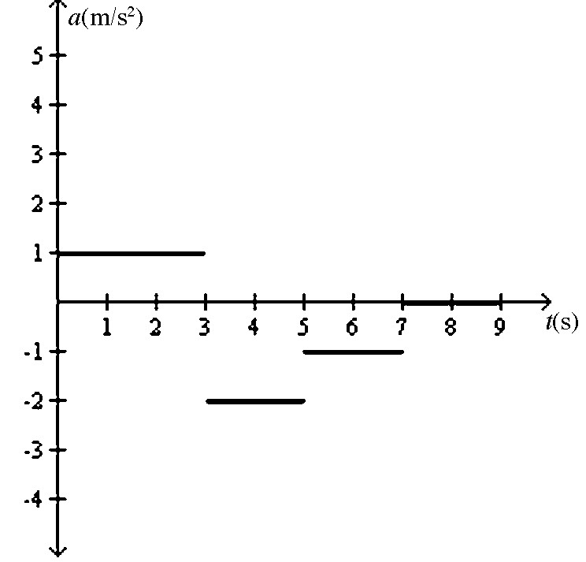
B)
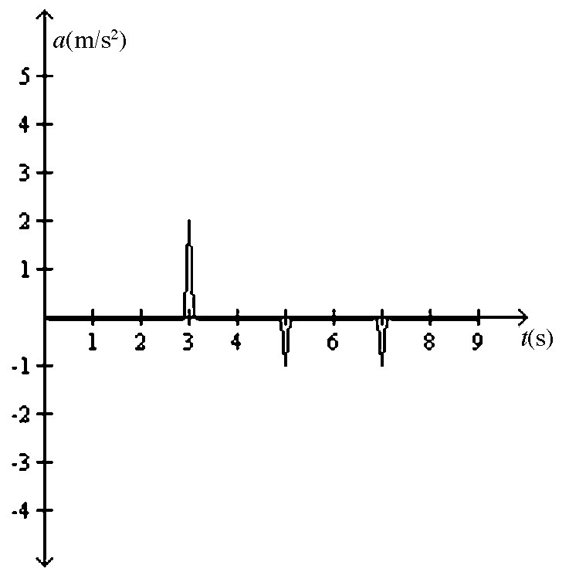
C)
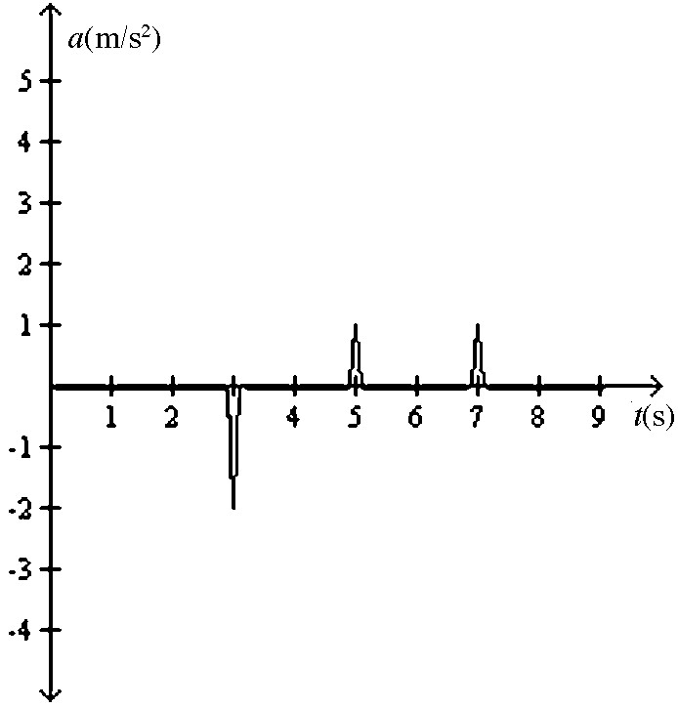
D)
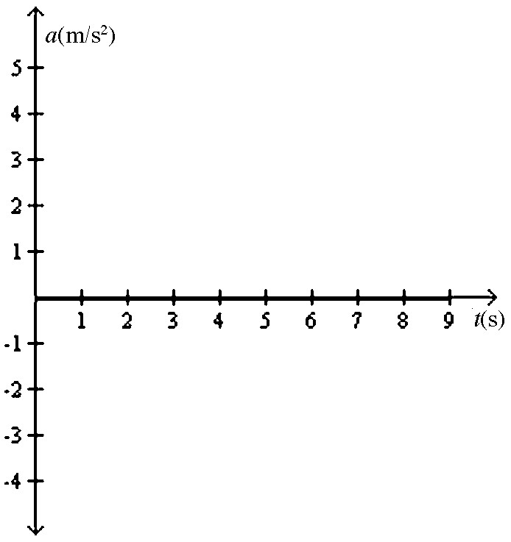
E)
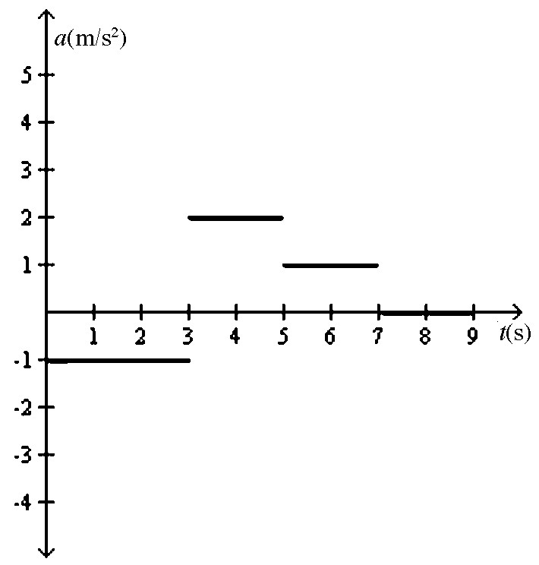
14) An object starts its motion with a constant velocity of 2.0 m/s toward the east. After 3.0 s, the object stops for 1.0 s. The object then moves toward the west a distance of 2.0 m in 3.0 s. The object continues traveling in the same direction, but increases its speed by 1.0 m/s for the next 2.0 s. Which graph below could represent the motion of this object?
A)
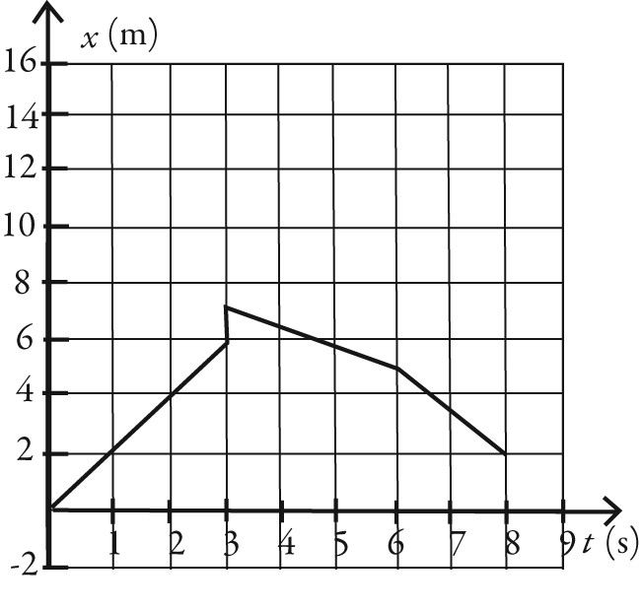
B)
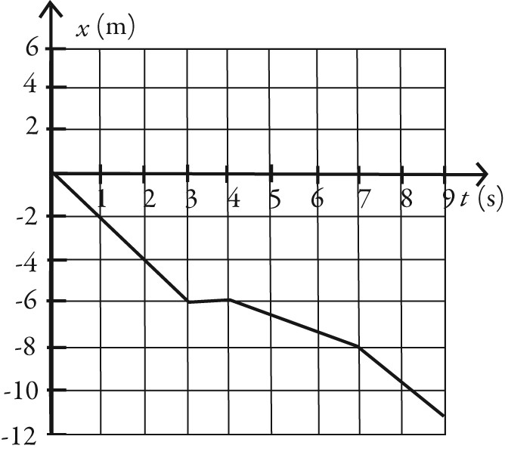
C)
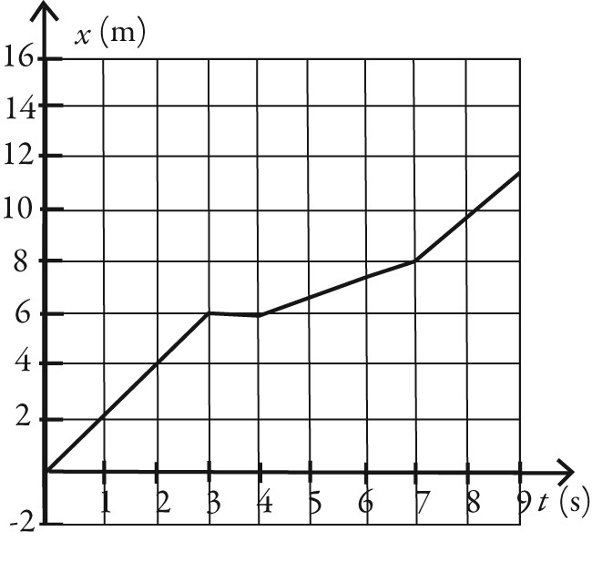
D)
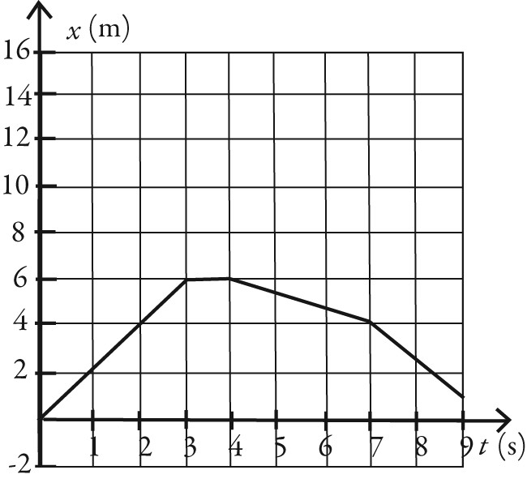

15) The figure shows the velocity of a particle as it travels along the x-axis. What is the direction of the acceleration at t = 0.5 s?
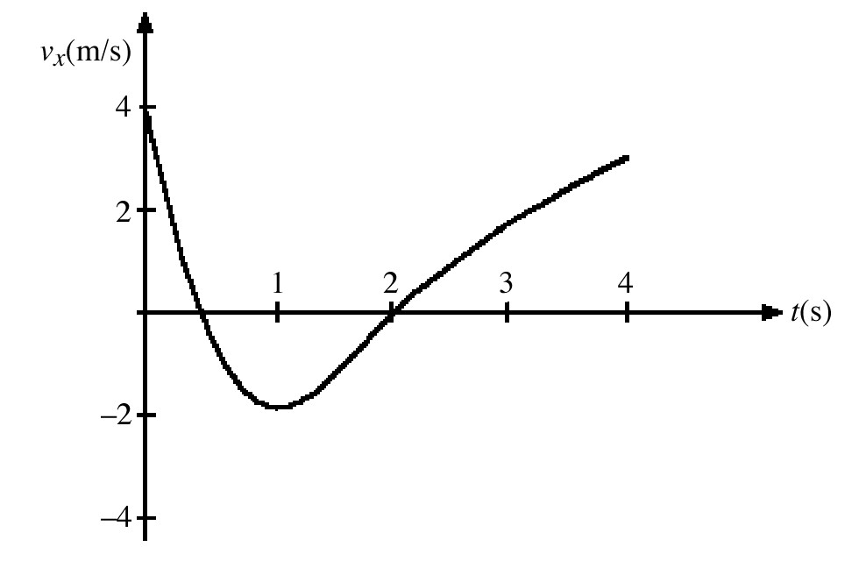
A) in the +x direction
B) in the -x direction
C) The acceleration is zero.
16) The figure represents the velocity of a particle as it travels along the x-axis. At what value (or values) of t is the instantaneous acceleration equal to zero?
A) t = 0
B) t = 0.5 s and t = 2 s
C) t = 1 s

17) A ball is thrown directly upward and experiences no air resistance. Which one of the following statements about its motion is correct?
A) The acceleration of the ball is upward while it is traveling up and downward while it is traveling down.
B) The acceleration of the ball is downward while it is traveling up and upward while it is traveling down.
C) The acceleration is downward during the entire time the ball is in the air.
D) The acceleration of the ball is downward while it is traveling up and downward while it is traveling down but is zero at the highest point when the ball stops.

18) Two objects are thrown from the top of a tall building and experience no appreciable air resistance. One is thrown up, and the other is thrown down, both with the same initial speed. What are their speeds when they hit the street?
A) The one thrown up is traveling faster.
B) The one thrown down is traveling faster.
C) They are traveling at the same speed.
19) Two objects are dropped from a bridge, an interval of 1.0 s apart, and experience no appreciable air resistance. As time progresses, the DIFFERENCE in their speeds
A) increases.
B) remains constant.
C) decreases.
D) increases at first, but then stays constant.
E) decreases at first, but then stays constant.

20) Which one of the following graphs could possibly represent the vertical position as a function of time for an object in free fall?
A)
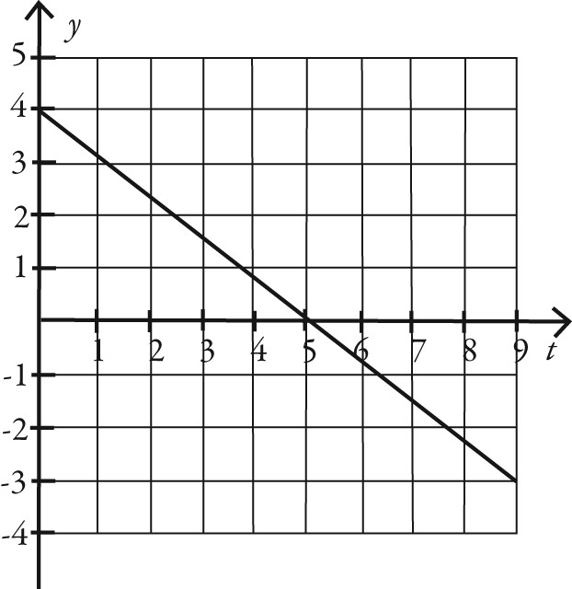
B)
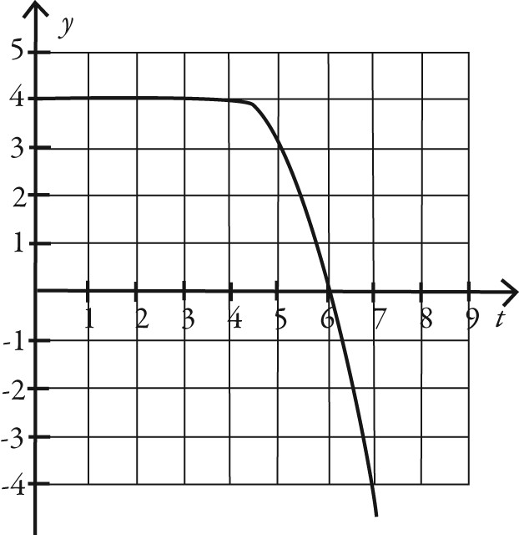
C)
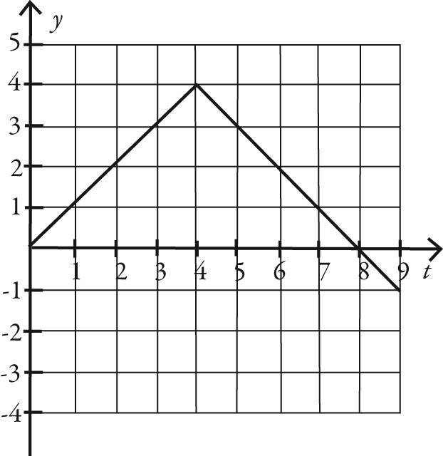
D)
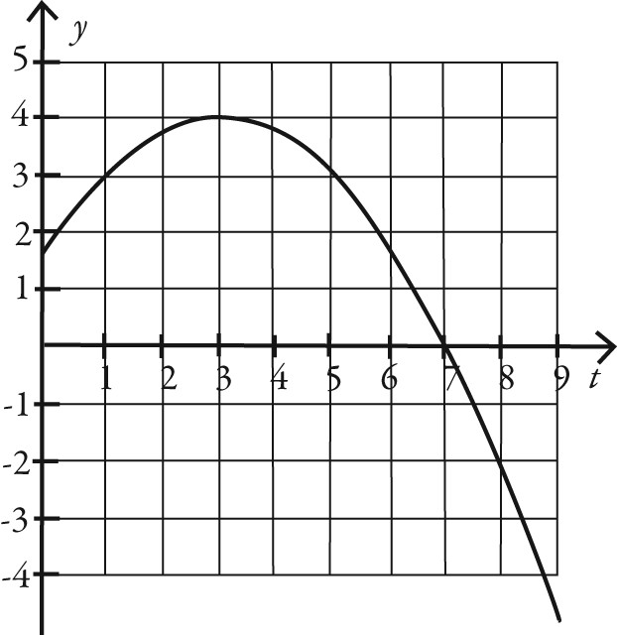
E)
